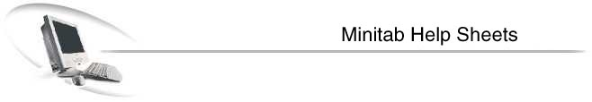
Minitab is a statistical package that performs business and academic analysis, (i.e. regression, correlation, standard deviation etc.)

To open Minitab: Start >Programs >Statistical Software >Minitab
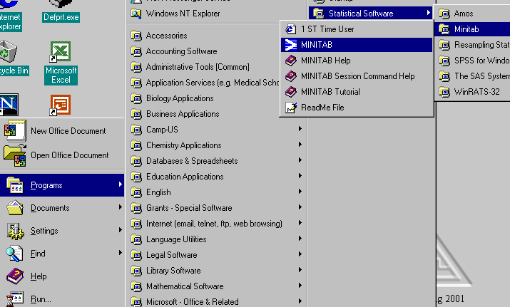
Entering Data: Two most common ways of entering data are either through the Session Window or Worksheet.

Session Window is command oriented; you have to know the commands in order to execute statistical tests.
Worksheet is similar to Excel and user friendly.

Session Window: used to enter data
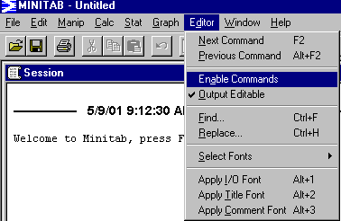
Menu bar >Editor >Enable Commands then MTB > prompt should appear in the session window.

NOTE: Never Type the MTB > prompt in the session window.
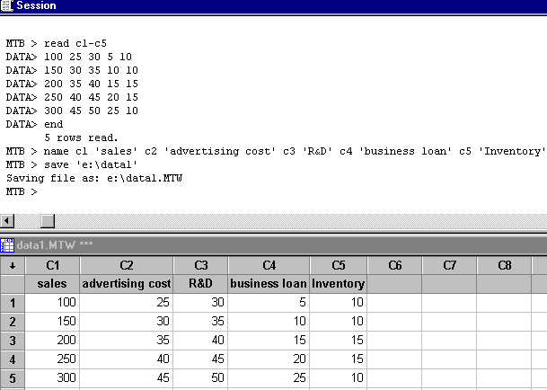
Step 1: always type read c1-c5 or read c1-c100 or number of colmuns needed to use by users.

Step 2: Data > prompt should appear, thus enter the numeric data.

Step 3: after entering data, type end.

Step 4: give names to the colmns entered data.

Step 5: to save the file just type ‘e:\data1’
Drive path = e or any other could be any other drive.
File name = data1 or anything else

Worksheet: used to enter data
Open Minitab Start >Programs >Statistical Software >Minitab
After it is opened just type the data directly in the worksheet.
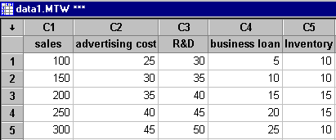
Worksheet looks and works similar to Excel.

Unlike session window you do not have to remember commands.

After entering data in the session window and worksheet, Statistical Tests can be conducted in two methods. First, method is through the session window (commands oriented). Second, method is through the menu bar.

Generating Statistical Tests through Menu Bar:
To run 1-Sample Z Test: Menu bar >Stat >Basic Statistics >1-Sample Z
Select the variables to run 1 sample z test. Under options there is a choice to change confidence level. Under graphs there is a choice to generate a Histogram etc…
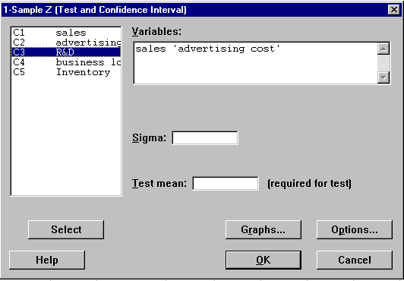
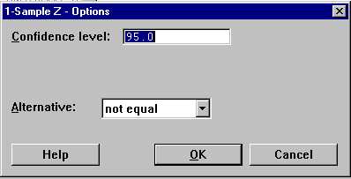

The result should display similar to the one below in the session window

One-Sample Z: sales, advertising cost

The assumed sigma = 0.05

Variable N Mean StDev SE Mean 95.0% CI
Sales 5 200.000 79.057 0.022 ( 199.956, 200.044)
Advertising 5 35.0000 7.9057 0.0224 (34.9562, 35.0438)

To run Discriptive Statistics: Menu bar >Stat >Basic Statistics >Display Descriptive Statistics
This test will give you Number of sample observation, Mean, Median, Trimmed Mean, Standard Deviation, and Standard Error of the Mean.

Generate Random Numbers: Menu bar >Calc >Random Data > Integer
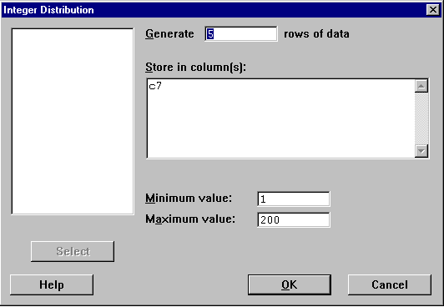
In the worksheet the following should be the result.

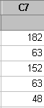

Transpose Columns into Rows: Menu bar >Manip >Transpose Columns
In the “Transpose the Following Column” box select the variables you want to transpose.
This should result in 90 degrees shift from columns to rows.

Free Minitab 13.0 software good for 30 days, can be downloaded from the following site: Users will need a ZIP disk to download this 18MB file.
http://www.minitab.com/products/13/demo/index.htm

OR visit www.minitab.com > Downloads > Minitab 13 Demo.

FAQs about Minitab:
Menu bar >Stat = this is where all the different statistical tests are located.
Menu bar >Graph = this is where all the different graphs options are available.

Commonly used Minitab commands in the session window:
C1 in the following examples means there is numeric data; these commands will also work with information entered in any other columns like c2 or c10.

MTB > OUTFILE ‘REPORT1’ = to create a file
MTB > READ C1-C100 = using columns from c1 to c100 to enter data
DATA > 100 25 30 5 10 = an example of numeric data entered
DATA > END = when finished entering numeric data
MTB > PRINT DATA IN C1 = this will print column c1
MTB > AVERAGE C1 = this will average of c1 column values
MTB > STDEV C1= this will give the standard deviation of column c1
MTB > SAVE ‘A:DATA1’ = this will save the file as data1 in the floppy drive
MTB > RETRIEVE ‘A:DATA1’ = this will re-open saved file
MTB > DESCRIBE C1 C3; = this will calculate mean, median, standard deviation
SUBC > BY C4. = min, max
MTB > HISTOGRAM C2
MTB > NOOUTFILE
MTB > STOP = will ask you if want to safe before closing minitab

How to Print:
- Printing Session window: clicked any where in the session window then menu bar > File >Print Setup (map to the right lab printer) >Print Sessions Windows > clicked OK
- Printing Worksheet: clicked any where in the Worksheet then menu bar > File >Print Setup (map to the right lab printer) >Print Worksheet > clicked OK

How to Save:
- Save project as <Filename.mpj>. This saves Session & Worksheet windows.
- Save Current Worksheet As <Filename.mtw>. This will save the worksheet in different formats like .xls, .txt,. mtw.
- Save Session Window As <Filename.txt>. This will save the session window.

Terms in the output and some definitions
N = number of data items in the sample that
Mean = Average
Median = Middle Number
TrMean = the 5% Trimmed Mean
StDev = Standard Deviation
SE Mean = Standard Error of the Mean
Minimum = Smallest Data Value or Maximum = Largest Data Value

