

St. Johns University Computer Labs Macs Help Sheets

Adobe Illustrator 8

Adobe Illustrator®: A computer aided drawing program used to create digital artwork Illustrator is a leading program for vector-based art for print, multimedia, or online graphics.
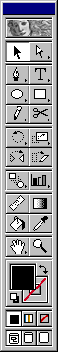

Here is the basic toolbar for Adobe Illustrator, as well as a list of the names of each button (from left to right). The letter in parentheses is the keyboard shortcut.
Selection (V) - Direct Selection (A).

Pen (P) - Type (T).
Ellipse (N) - Rectangle (M).
Pencil (Y) - Scissors (C).

Rotate (R) - Scale (S).
Reflect (O) - Shear (W).

Blend (B) - Graphs (J).

Measure (U) - Gradient (G).
Paint Bucket (K) - Eyedropper (I).

Hand (H) - Zoom (Z).

Fill - Stroke.
Default Colors (D) - Swap fill/stroke (X).

Color - Gradient - None.
Standard - Full/Menu - Full.

Illustrator Project:
3 D effects with Blend tool

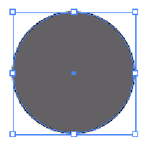
Hold down a shift key and draw a circle with Ellipse tool.

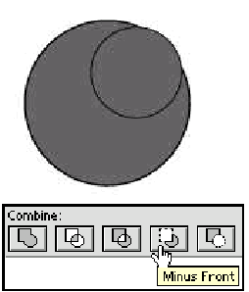
Draw a smaller circle and place it on top right hand corner of the original circle.

Select both circle and minus front from the pathfinder.



Copy and paste cropped object and pick rainbow color for one object and pick chrome color for the second object.

Select both of the objects then from menu bar select objects and then chose blend and make.

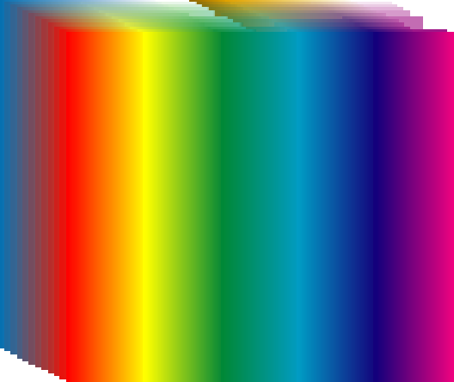

Illustrator Project 2: To perform the following, edit << select all.

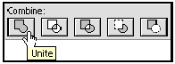

Unite between any two object causes back object to convert to front object color.
Select both objects then click on unite.



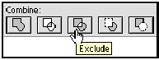Exclude is when you want to cut out the overlapped part of the object. Select all and then click on the exclude.

Select the rectangular rotate it to right hand side & edit << select all << exclude.


Adding Text: Click inside & type “circle & rectangular” and type to the right hand side of the both object shapes vertically.
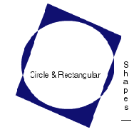

To Save: File << Save a copy
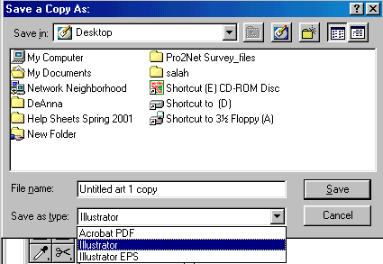

When saving in Illustrator always use Illustrator format.

Illustrator extension is
. ai.
This is also compatible with Photoshop.

